AD LIFECYCLE ARTIFACT | External Design Document – V4.3  Detail Component Design
Application: OMS Roles and Responsibilites Administrator | Project Name: Order Management System
Module/Component/Executable:  Security Admininstrator | Project Initiation Code: OMS
Author: Raghu K | Project Code:
Language: Java | Time Tracking Code:
The Internal Design describes the new module or modifications to an existing module to meet the desired functional changes as specified in the External Design. The document should reference all aspects of the module being modified including detailed references to inputs and outputs. The document should also include test-planning guidelines to support Unit Testing.
1 VERSION HISTORY 2
2 OVERVIEW 2
2.1 Summary 2
2.2 Out of Scope 2
2.3 Architecture Overview 4
3 REQUIREMENTS TRACEABILITY MATRIX 4
4 FUNCTIONAL & LOGICAL SPECIFICATIONS 5
5 DESIGN ASSUMPTIONS 6
6 DESIGN RISKS 7
7 ARCHITECTURE IMPLICATIONS 7
8 DATABASE MODEL 8
9 QUALITY CONTROL 9
10 INTERNAL DESIGN SIGNOFF (AD Only) 9
11 APPENDIXES 10

VERSION HISTORY

Version | Description of Changes | Date | Author
1.0 | Initial release | 11/14/05 | Raghu Kakanavaram

OVERVIEW

Summary

This document describes the design of the Role – Action mapping functionality in OMS. This implementation has two components:

- Role – Action Administration using the Security Administration tool

The role-action mapping involves fetching all the “OMS roles” from the system of record (assumed to be the IRI Corporate LDAP system), linking these roles to objects in OMS (such as Orders, Bill of Materials, Process plans etc.,) and mapping out specific actions (such as Create, Update, Submit, Cancel etc.) for each of the OMS roles.

- Deploy the roles-to-action mapping via the Security API in the OMS application

The completed role-to-action mapping definition is persisted in a Selectica security mapping database schema. In the OMS application, the Security API reads this information into memory (configurable as one-time load, timed cache refresh or dynamic read). The OMS application will use the Security API to determine if a user is authorized for a certain action.

Out of Scope

- Creating and managing users (user names and passwords) is out of scope for this system. It is assumed that the IRI Corporate LDAP system will provision this.
- Creating and managing roles (for each of the MK factory’s components) is out of scope for this system. It is assumed that the IRI Corporate LDAP system will provision this.
- Mapping users to OMS roles is out of scope for this implementation. It is assumed that all users are mapped to roles/groups in the IRI Corporate LDAP system.
- The current implementation does NOT allow for “dynamic” or “conditional” assignment of actions. For Example: “Order Placer” is an OMS role that has a “Delete” action provisioned on the “Order” object. However, if the “Delete” action is conditional that it is only allowed if the product ordered is “Market Tracking” or if the order’s price is less than $100000 etc., such a scenario is not currently supported. However, the implementation can be enhanced to support such dynamic or conditional assignments by using a KBS to determine the assignment at run-time.

Architecture Overview

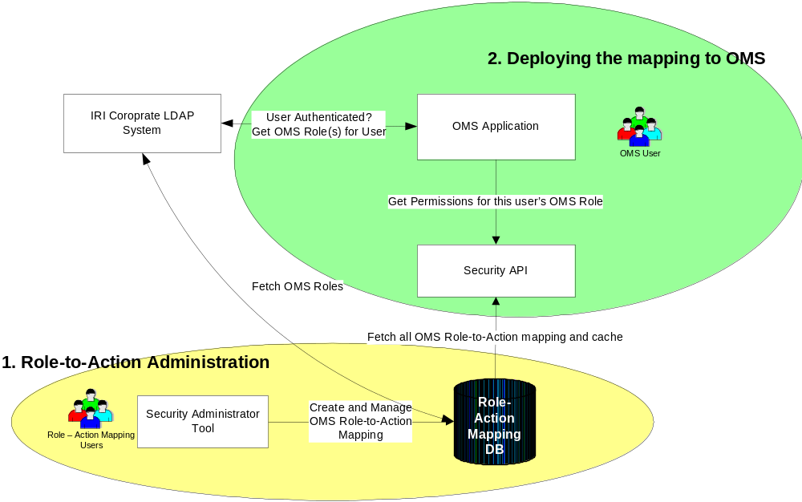

REQUIREMENTS TRACEABILITY MATRIX

E.D. # | External Design Functional Change | I.D. # | Internal Design Functional Change

FUNCTIONAL & LOGICAL SPECIFICATIONS

1) Role-to-Action Administration:

The Selectica Security Administration tool is a web-based application that allows authorized users to create and manage application roles. The tool allows for linking actions (privileges, responsibilities) to these roles on specific application objects. The following tasks can be performed using the Security Administrator tool:

- Create application roles for the OMS application.
- Define product permissions and map these permissions to new or existing roles.
- Create aggregate roles called role groups. An aggregate role, or role group, is a grouping of other roles within or between products. A role group enables you to combine roles across products into a single, manageable role that can be assigned to users.
- Create child roles. You can create hierarchical structures for roles by defining subordinate roles called child roles. A role that contains child roles has all of the permissions and access rights of the child roles they contain.
- Upload user and role data in bulk. Using the Security Administrator console, you can bulk upload user and role data from an XML file.

In the current implementation, the creation and management of user roles is assumed to be in the IRI Corporate LDAP system and not in this Security Administration tool.

The following is a typical implementation/usage of the Security Administration tool for OMS:

- There are two “OMS roles” for users logging in to MK:
  - Order Placer
  - Order Approver

- There are several objects/resources that are created and maintained in OMS:
  - Draft Orders
  - Committed Orders
  - Bill-of-Materials
  - Process Plans

- There are specific actions that users can execute in OMS:
  - Create
  - Update
  - Submit
  - Cancel

The Security Administration tool allows the mapping of roles to actions for each specific object as depicted below:
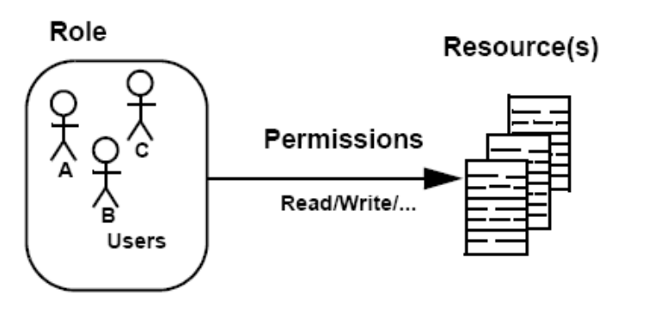

Specifically, the mapping matrix for the OMS roles, actions and objects is shown below:

OMS Role | Allowed Actions/Permissions on OMS Objects
OMS Role | Draft Order | Committed Order | Bill-of-Materials | Process Plan
Order Placer | Create, Update, Submit | Copy | TBD | TBD
Order Approver | Submit | Update, Submit, Copy | TBD | TBD

These mapping definitions are saved in the repository for use in the OMS application.

2. Deploying the saved mapping definition to the OMS application:

A user logging in to OMS is authenticated via the IRI Corporate LDAP service. If the authentication is successful, the LDAP service returns to OMS a list of all the OMS roles for this user. The Security API is invoked in the OMS application. The Security API fetches the matrix of privileges for all OMS roles on each OMS object. Depending on the need for dynamic refresh, the Security API can be configured to one of the following settings:

- Cache the matrix on load (best application performance, no reload)
- Timed-reload (good performance, configurable cache-reload mechanism)
- Dynamic look-up (average performance,

The OMS application uses the above information to render the OMS screens appropriately and allows the users access only to the allowed actions on the OMS objects.

DESIGN ASSUMPTIONS

- User authentication (creating and managing user names and passwords) is provisioned in the IRI LDAP system.
- Creation and maintenance of OMS user roles/groups is provisioned in the IRI LDAP system.
- Mapping users to OMS user roles/groups is provisioned in the IRI LDAP system.
- OMS will interact with the IRI LDAP via a service call to obtain the OMS role for a user as part of user authentication. A sample interaction between OMS and LDAP could be: LDAP Service Request containing the following parameters: Username, Password and the requesting application (OMS). The result (output) from the LDAP Service could be: Authentication Success/Failure and OMS role of the user (if authentication succeeds).
- The Selectica Security Administration module currently (out-of-the-box) supports role-to-action mapping that is pre-defined (i.e. not dependent on any run-time parameters or conditions). For example:

DESIGN RISKS

- This implementation assumes that the IRI Corporate LDAP system will be available. The completion of this module depends on the availability of a working authentication service from the LDAP system that OMS can integrate with. Any delay/non-availability of the required LDAP service constitutes a dependency/integration risk. To mitigate this, we may have to stub-out the integration with a static set of users (un-authenticated) and OMS roles.

- The current design focuses on developing the infrastructure to support a simple role-to-action mapping. Two roles (OMS Order Placer and OMS Order Approver) will be provisioned with a set of five actions (Create Order, Update Order, Submit Order, Delete Order, Copy Order) on the Order object. The implementation is flexible and scalable to accommodate multiple roles and multiple actions on all OMS objects. However, any requirement for “conditional” or “dynamic” role assignment to action is out of scope and constitutes a scope risk. Any requirements to handle “dynamic” role-to-action mapping would be considered only after a proof of technology/concept exercise is conducted.

ARCHITECTURE IMPLICATIONS

DATABASE MODEL

The database model for the Selectica Security Admin module to store the role-to-action mapping is shown below:

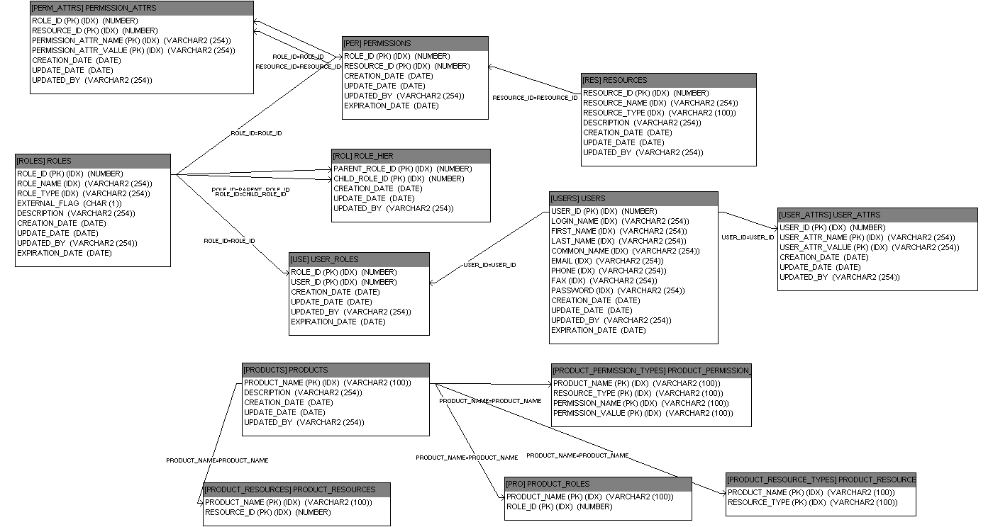

QUALITY CONTROL

INTERNAL DESIGN SIGNOFF (AD Only)

Signoff - Name | Functional Area | Signoff Date

APPENDIXES

